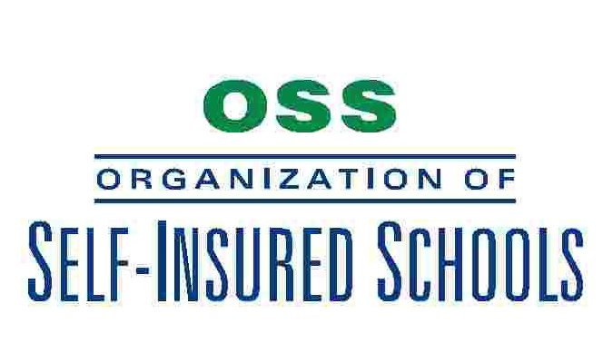
April 16, 2015

MEMORANDUM TO: JPA Liaisons / Safety Officers / Contact People

SUBJECT: Child Abuse Training Verification for
Certified and Classified Substitutes

As you may recall, legislation effective January 1st, requires all staff members to annually complete child abuse reporter training (www.getsafetytrained.com – Child Abuse Reporting for Educators) within the first six weeks of the beginning of the school year. Also, as noted in the March 2nd communication, each school district is required to submit its own request “Reporting on Alternative Training Provided for Mandatory Reporters” form to the CDE.

The question has arisen regarding how to verify that substitutes, certificated and classified, are in compliance. A certification of completion may be printed upon completion of the afore mentioned online class. This certificate will confirm compliance with the legislation.

If you have any questions, please contact me.

Henry Brock
Risk Manager
riskmanager@cvip.net

