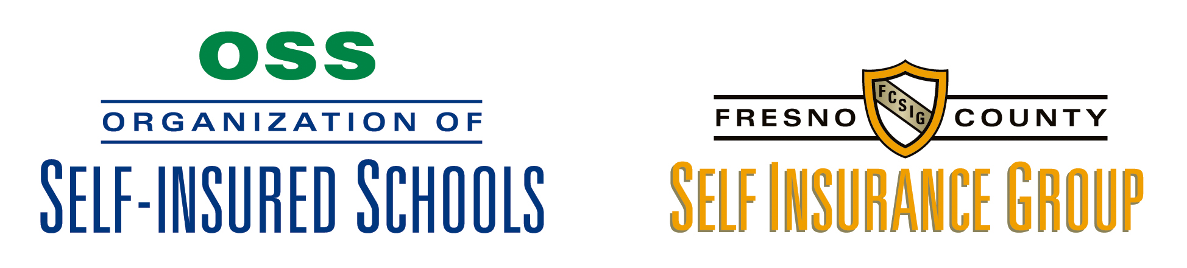

May 29, 2014

MEMORANDUM FOR: JPA Liaisons, Contact People/Safety Officers, Servicing Agents

SUBJECT: Applying for Playground Fall Material Reimbursement

Prior to submitting an application for reimbursement for playground equipment fall material (ground rubber tires, etc.), if the district notes that one of the requirements is an audit/inspection conducted by a California Playground Certified Inspector (CPSI) after the installation and before reimbursement is made, the district may wish to request the JPA provide an inspection prior to submitting the application. By approaching the application process in this manner, a district will be able to evaluate the costs, if any, of bringing the equipment into compliance with all of the National Playground Safety Institute Standards, as is required by California law. Repairs and replacement can become very expensive and by utilizing this process a district will have an idea of its encumbrance prior to submitting the application. A district may request that OSS provide both before and after installation inspections.

Henry Brock
Risk Manager

