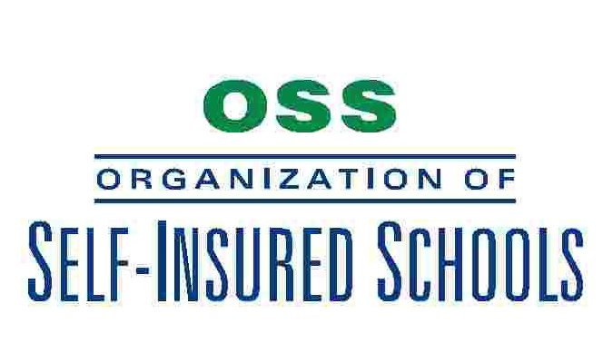

December 3, 2012

MEMORANDUM FOR: JPA Liaisons, Contact People/Safety Officers
Servicing Agents

SUBJECT: Utilizing Assigned Defense Counsel

The purpose of this bulletin is to advise OSS members of the importance of using assigned defense counsel attorneys from the NCR approved defense panel to defend liability claims. NCR has established a panel of defense attorneys that are specialists in the area of California Governmental tort defense practices. OSS members may retain separate legal counsel for non-liability issues, but if separate legal counsel is retained for NCR covered legal defense issues they do so at their own expense. In rare cases, it may be appropriate for NCR to consider using non-approved defense counsel to represent a member. Said member must request the use of non-approved counsel and such request must be made to NCR at the earliest awareness circumstances that may lead to potential claim. Any member that retains non-approved counsel, then seeks reimbursement of legal fees for those services at a later date, will normally be denied.

For questions regarding the use of approved or non-approved legal counsel,
please contact Erik Knak (530-247-1049) or Bill Tucker (559-819-1025).

Bill Tucker
Administrator/Broker

